**RDBMS PROJECT FILE**

Submitted for the partial fulfilment of the

Degree of

Bachelor of Technology (Computer Science and Engineering)



**Submitted By: Submitted To:**

Sparsh Gagneja Pf. Mandeep Kaur D3CSB1

**1706522**

Department of Computer Science & Engineering

**Guru Nanak Dev Engineering**

**College, Ludhiana**

**CONTENTS**

1. INTRODUCTION. 1
2. COMPANY ER DIAGRAM 2
3. COMPANY DATABASE SCHEMA 3
4. ENTITY DESCRIPTION 4-8
5. TABLE DATA 9-11
6. QUERIES EXECUTED 12-16

**INTRODUCTION**

We need to create a database schema design based on the following (simplified) requirements of the COMPANY Database:

◆ The company is organized into branches. Each branch has a name, unique ID and an employee who manages the branch. We keep track of the branch supplier by storing the records of the supplier name and the supply type. A branch may have several branch suppliers.

◆ Each branch handles a number of clients.

◆ We store each employee’s ID number, address, salary, sex, and birthdate.

◆ Each employee works for one branch but may work with several clients.

◆ One employee manages one branch. We keep a track of the start time of management for the employee for a branch.

◆ We also keep track of the directed supervisor of each employee and the supervisee associated with each employee.

◆ An employee may work with a number of clients.

◆ For each client, we keep track of their name, unique ID, relationship to the employee.

# Company ER Diagram

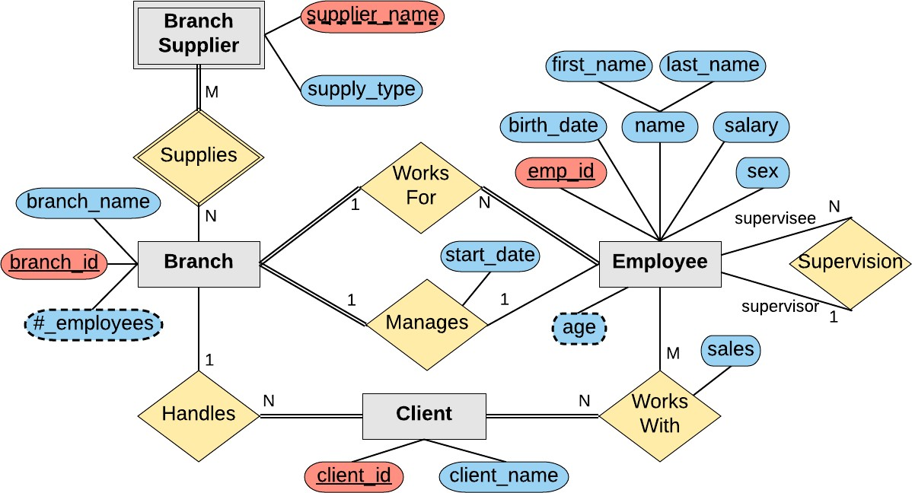

*Company Database Schema*

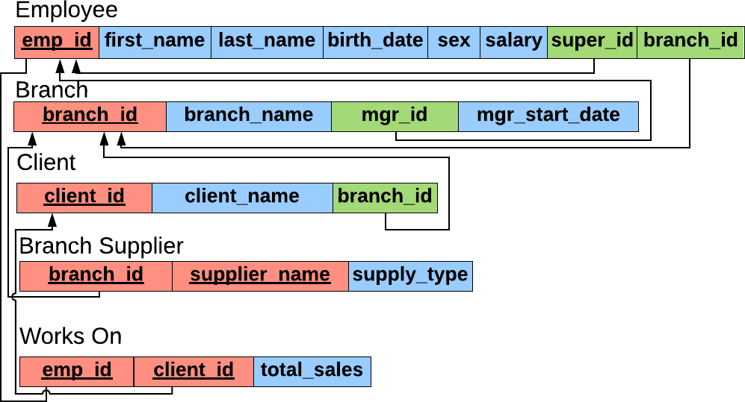

## ENTITY DESCRIPTION

EMPLOYEE

|  |  |  |
| --- | --- | --- |
| **FIELD** | **DATATYPE** | **KEY** |
| **Emp_id** | **Int** | **Primary key** |
| **First_name** | **VARCHAR(40)** |  |
| **Last_name** | **VARCHAR(40)** |  |
| **Birth_day** | **DATE** |  |
| **SEX** | **VARCHAR(1)** |  |
| **Salary** | **Int** |  |
| **Super_id** | **Int** |  |
| **Branch_id** | **Int** |  |

QUERIES

**CREATE TABLE employee ( emp_id INT PRIMARY KEY, first_name VARCHAR(40), last_name VARCHAR(40), birth_day DATE,**

**sex VARCHAR(1),**

**salary INT, super_id INT, branch_id INT,**

**FOREIGN KEY(branch_id) REFERENCES branch(branch_id) ON DELETE SET NULL, FOREIGN KEY(super_id) REFERENCES employee(emp_id) ON DELETE SET NULL**

**);**

BRANCH

|  |  |  |
| --- | --- | --- |
| **FIELD** | **DATATYPE** | **KEY** |
| **Branch_id** | **Int** | **Primary key** |
| **branch_name** | **VARCHAR(40)** |  |
| **Mgr_id** | **Int** | **Foreign key** |
| **Mgr_start_date** | **Date** |  |

QUERIES

**CREATE TABLE branch ( branch_id INT PRIMARY KEY, branch_name VARCHAR(40), mgr_id INT,**

**mgr_start_date DATE,**

**FOREIGN KEY(mgr_id) REFERENCES employee(emp_id) ON DELETE SET NULL**

**);**

**CLIENT**

|  |  |  |
| --- | --- | --- |
| **FIELD** | **DATATYPE** | **KEY** |
| **client_id** | **Int** | **Primary key** |
| **client_name** | **VARCHAR(40)** |  |
| **branch_id** | **Int** | **Foreign key** |

QUERIES

CREATE TABLE client ( client_id INT PRIMARY KEY, client_name VARCHAR(40), branch_id INT,

FOREIGN KEY(branch_id) REFERENCES

branch(branch_id) ON DELETE SET NULL

);

WORKS_WITH

|  |  |  |
| --- | --- | --- |
| **FIELD** | **DATATYPE** | **KEY** |
| **Emp_id** | **Int** | **Primary key** |
| **Client_id** | **Int** | **Foreign key** |
| **Total_sales** | **Int** |  |

QUERIES

CREATE TABLE works_with ( emp_id INT,

client_id INT, total_sales INT,

PRIMARY KEY(emp_id, client_id),

FOREIGN KEY(emp_id) REFERENCES

employee(emp_id) ON DELETE CASCADE,

FOREIGN KEY(client_id) REFERENCES

client(client_id) ON DELETE CASCADE

);

BRANCH_SUPPLIER

|  |  |  |
| --- | --- | --- |
| **FIELD** | **DATATYPE** | **KEY** |
| **branch_id** | **Int** | **Primary key** |
| **Supplier_name** | **VARCHAR(40)** | **Primary key** |
| **Supply_type** | **VARCHAR(40)** |  |

QUERIES

CREATE TABLE branch_supplier ( branch_id INT,

supplier_name VARCHAR(40), supply_type VARCHAR(40),

PRIMARY KEY(branch_id, supplier_name),

FOREIGN KEY(branch_id) REFERENCES

branch(branch_id) ON DELETE CASCADE

);

## TABLE DATA

**mysql> select * from employee;**

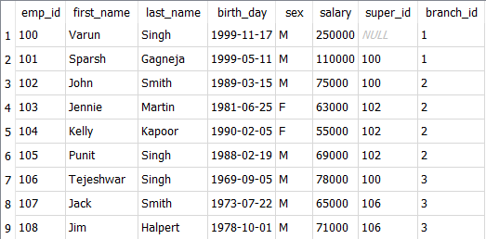

**mysql> select * from branch;**

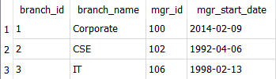

**mysql> select * from client;**

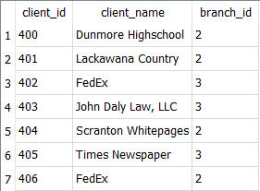

**mysql> select * from works_with;**

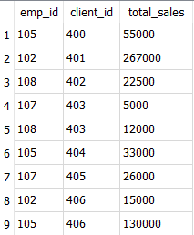

**mysql> select * from branch_supplier;**

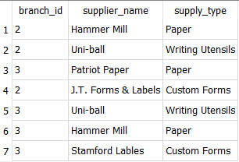

## QUERIES EXECUTED

1. **Find all employees ordered by salary**

**SELECT * from employee ORDER BY salary DESC;**

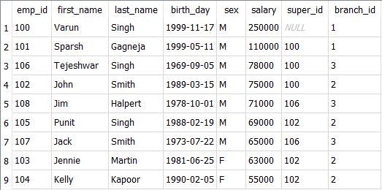

1. **Find all employees born between 1970 and 1975**

**SELECT * FROM employee WHERE birth_day BETWEEN '1970-01- 01' AND '1975-01-01';**



1. **Find all female employees at branch 2**

**SELECT * FROM employee WHERE branch_id = 2 AND sex = 'F';**

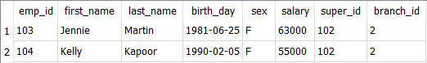

1. **Find the total sales of each salesman**

**SELECT SUM(total_sales), emp_id FROM works_with GROUP BY client_id;**

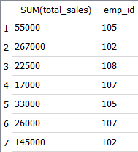

1. **Find any employee born on the 10th day of the month**

**SELECT * FROM employee WHERE birth_day LIKE ' 10%';**



1. **Find a list of all clients & branch suppliers' names**

**SELECT client.client_name AS Non-Employee_Entities, client.branch_id AS Branch_ID FROM client**

**UNION**

**SELECT branch_supplier.supplier_name, branch_supplier.branch_id FROM branch_supplier;**

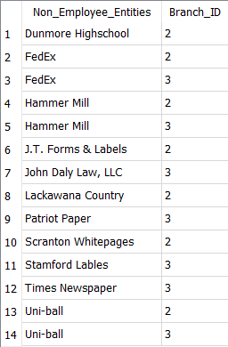

1. **Add the extra branch**

**INSERT INTO branch VALUES(5, "ME", NULL, NULL);**

**SELECT employee.emp_id, employee.first_name, branch.branch_name FROM employee**

**JOIN branch**

**ON employee.emp_id = branch.mgr_id;**

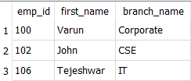

1. **Find names of all employees who have sold over 50,000**

**SELECT employee.first_name, employee.last_name FROM employee**

**WHERE employee.emp_id IN (SELECT works_with.emp_id FROM works_with**

**WHERE works_with.total_sales > 50000);**

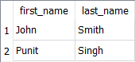

1. **Update the name of Jack with Vinayak**

**UPDATE employee SET first_name='Vinayak' WHERE first_name='Jack';**

**SELECT * FROM employee;**

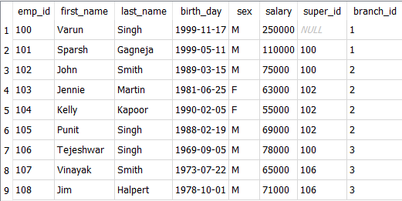

1. **Delete the employee whose name is Vinayak**

**DELETE FROM employee WHERE first_name='Vinayak'; SELECT * from employee;**

